**JAYPEE INSTITUTE OF INFORMATION TECHNOLOGY, NOIDA-62**

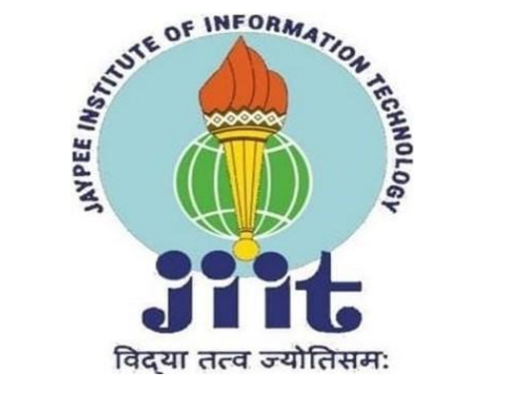

**PROJECT SUMMARY SHEET**

**Topic – MOVIE RECOMMENDATION SYSTEM**

Team Members:

Sanskar Khandelwal 21103172 B6

Yash Aeron 21103207 B8

Priyanshu Jain 21103205 B8

1. **Motivation behind the project:**

The project aims to address the growing demand for effective movie recommendation systems. In an era of vast digital movies and series, the need to enhance user experience and facilitate movie discovery motivated the development of a sophisticated Movie Recommendation System.

1. **Type of Project:**

It is the development cum research project.

1. **Overall design of the project**

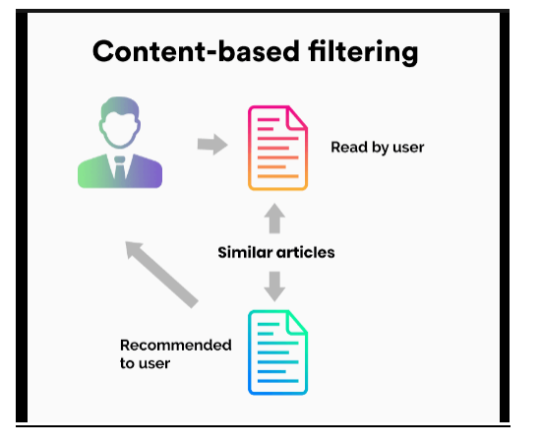

1. **Technologies used:**

* Front end: HTML, CSS
* Backend: Python
* IDEs: VScode and Jupyter Notebook
* Database: MySQL
* Machine learning model: Content-based filtering
* Dependencies used: pandas, numpy, nltk, flask
* Algorithms used for training the model:
  + User Interaction Interface
  + vectorisation
* Algorithm used for recommendation: Support Vector Machine(cosine similarity)

1. **PROPOSED METHODOLOGY:-**

The project follows a comprehensive methodology involving:

* Requirements Gathering: Understood the requirements and user needs for the recommendation system and Identified key features, such as personalized recommendations, user interface design. Broke down the project into manageable tasks and prioritize them.
* Data Acquisition and Pre-processing: Utilizing the tmdb dataset, handling missing values, and feature engineering.
* Data Exploration and Analysis: Employing data visualization techniques to understand trends in movie genres, ratings and preferences.
* Clustering Algorithms: Utilizing vectotisation to group movies based on genres, directors and user ratings.
* User Interaction: Developing a user-friendly interface for input and exploration using flask module and web development.
* Recommendation Engine: Building a recommendation engine based on cosine similarity between genres of different movies.

1. **DESCRIPTION OF WORK:-**

* Data Collection: Gather a large dataset of movie-related information, including details about movie, directors, genres, user preferences, and cast.
* Data Preprocessing: Clean and preprocess the collected data to handle missing values, outliers, and inconsistencies. Extract relevant features from the data that can be used to describe movies, genres, and user preferences.
* Exploratory Data Analysis (EDA): Explore and analyze the data to gain insights into patterns, trends, and relationships. Understand the distribution of genres, popular directors, and user preferences.
* Prototyping: Created prototypes of the user interface using HTML and CSS to visualize the layout and design. Gathered initial feedback on the interface design and usability.
* Integration with User Interface: Implement the recommendation system into the user interface of the movie application or platform.
* Scalability and Deployment: Ensure that the recommendation system is scalable to handle a large number of users and a growing music catalog. Deploy the recommendation system in a production environment, monitoring its performance and making adjustments as needed.

1. **DIVISION OF WORK AMONG STUDENTS:-**

The team collaborated on various aspects, with responsibilities divided as follows:

Sanskar khandelwal: Back-end  
Yash Aeron: Front-end  
Priyanshu Jain: Front-end

1. **RESULT:-**

The project successfully achieved the development of a functional Movie Recommendation System, providing accurate recommendations based on user preferences and different genres.

1. **CONCLUSION:-**

The project concludes with a promising outcome, showcasing the potential of the Movie Recommendation System to enhance movie discovery and user experience. Future enhancements and continuous improvement strategies are outlined for sustained development.

(Detailed information and analysis can be found in the project report.)